BPMN notes
Enterprise strategic BPMN
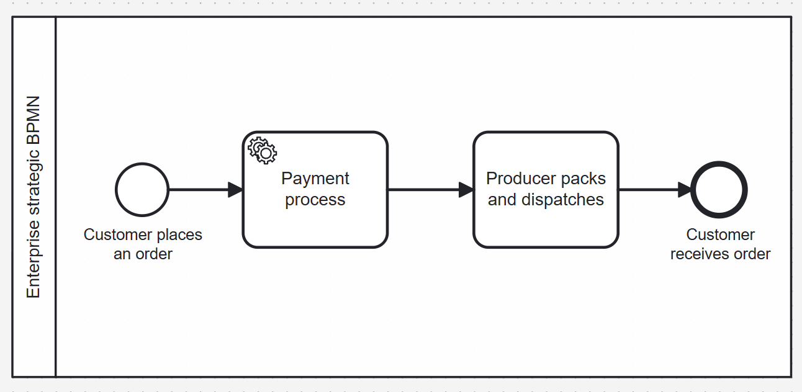

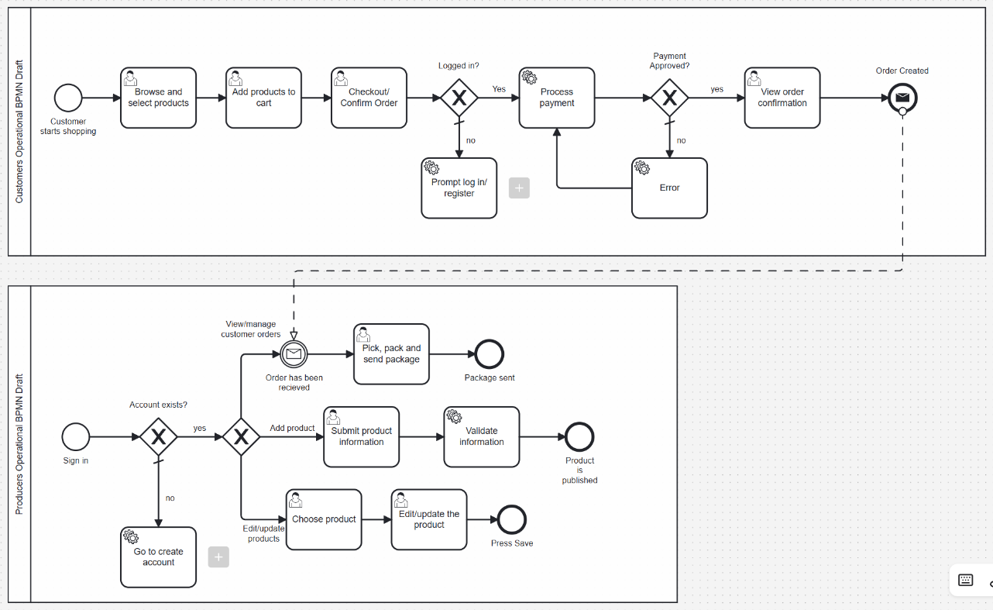
Original BPMN’s made. Too much detail made them irrelevant (operational)

Functionalities
From Case 1:
- Login → new product → add info → validate info → publish product
↓
Error/producer adds the info

- Update quantity and seasonal availability → stock==0, automatically unavailable → stock>0 & season, available

